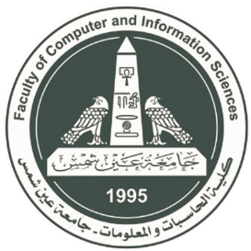

جامعة عين شمس  
كلية الحاسبات و المعلومات  
قسم نظم المعلومات

Ain Shams University

Faculty of Computer & Information Sciences

Information Systems Department

**Live Data Tracking   
&  
Analysis Dashboard**

**By:**

Wardshan Essam El Saied

Youssef Gamal Mohamed

Youssef Morris Hakim

Wassim Joesph Hakim

Mina Ossama Fouad

**Under Supervision of:**

Dr. Wedad Hussein,

Assistant Professor,

Information Systems Department,

Faculty of Computer and Information Sciences,

Ain Shams University.

Menna Maged,

Teaching Assistant,

Information Systems Department,

Faculty of Computer and Information Sciences,

Ain Shams University.

**July - 2021**